Build a Bird – Student Activity

Cut out some of these shapes and paste them together to create a bird that could live in a swampy area and catch small fish

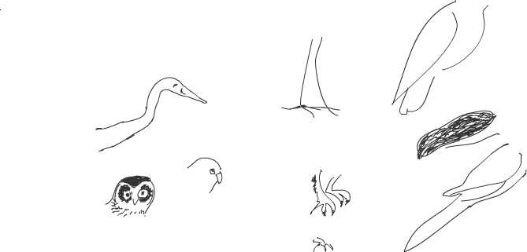

Draw and colour a Wetlands habitat for the bird you have created in your Science book and then paste your bird into this habitat.

What other birds can you create from the shapes?
What kind of habitats would these birds be likely to live in and why?

Draw, colour and name habitats for each of these birds in your Science book and then paste each bird into its habitat.

